`My questions in C programming.

Que. Define data types in c programming?

Ans.

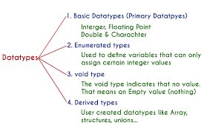

M2

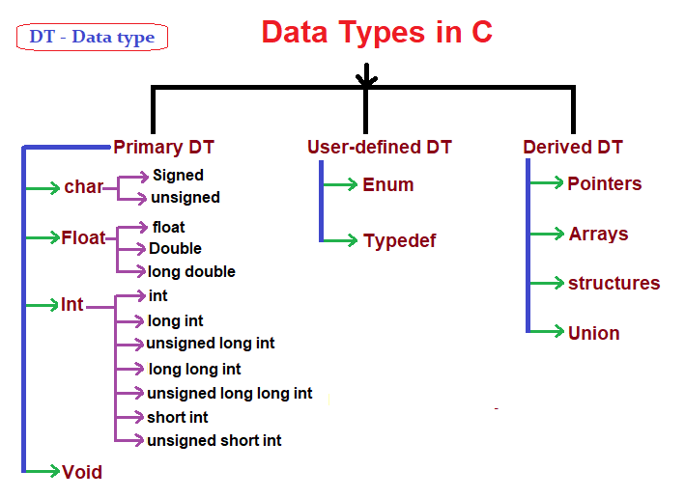

## Que. Flowchart to Find Factorial of a Number.

## Ans.

## factorial of a number

Que. What is meaning of signed and unsigned in c programming?

Ans. In C, signed and unsigned are **type modifiers**. You can alter the data storage of a data type by using them: signed - allows for storage of both positive and negative numbers. unsigned - allows for storage of only positive numbers.

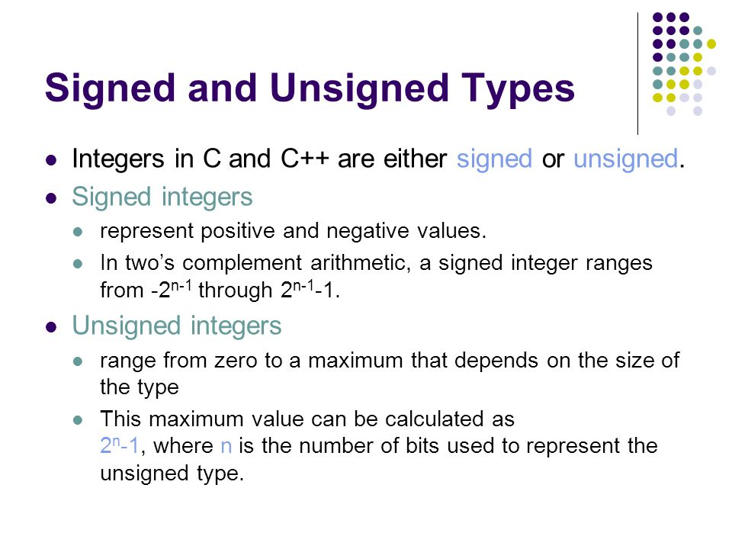

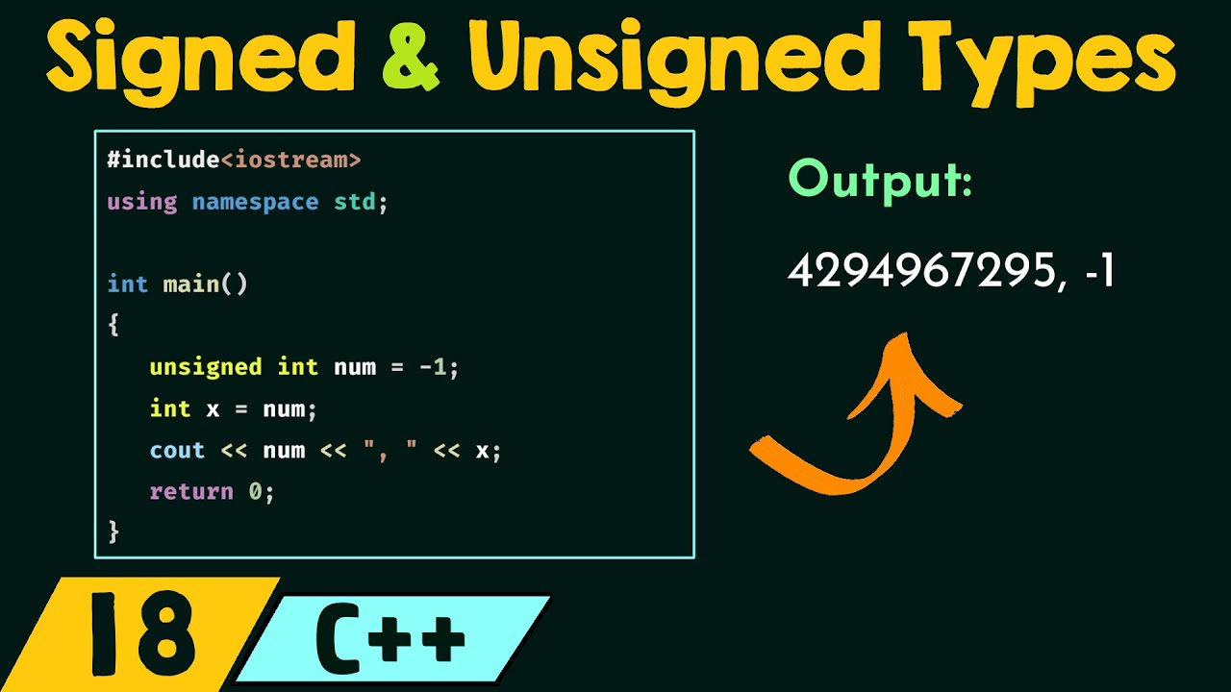

Que. What is the difference between while loop and do while loop.

## Ans. While vs. Do While

Here is an important difference between While and Do While Loop:

|  |  |
| --- | --- |
| **While** | **Do While** |
| It checks the condition first and then executes statement(s) | This loop will execute the statement(s) at least once, then the condition is checked. |
| While loop allows initialization of counter variables before starting the body of a loop. | Do while loop allows initialization of counter variables before and after starting the body of a loop. |
| It is an entry controlled loop. | It is an exit controlled loop. |
| We do not need to add a semicolon at the end of a while condition. | We need to add a semicolon at the end of the while condition. |
| In case of a single statement, we do need to add brackets. | Brackets are always needed. |
| In this loop, the condition is mentioned at the starting of the loop. | The loop condition is specified after the block is executed. |
| Statement(s) can be executed zero times if the condition is false. | Statement is executed at least once. |
| Generally while loop is written as:  while (condition) {  Statements; // loop body  } | Generally do while loop is written as:  do{  Statements; //loop body  } while (condition); |

Que. Role of operating system in computer?

Ans. An operating system is the most important software that runs on a computer. It **manages the computer's memory and processes, as well as all of its software and hardware**. It also allows you to communicate with the computer without knowing how to speak the computer's language.

Que. Tell me something about operating system.

Ans.

Below are the main functions of Operating System:

* Que. What is the condition of using double?

Ans. A double is a data type in C language that **stores high-precision floating-point data or numbers in computer memory**. It is called double data type because it can hold the double size of data compared to the float data type. A double has 8 bytes, which is equal to 64 bits in size.

Que. What is the meaning of return 0 in c programming?

Ans. The return 0 means **success** and returning a non-zero number means failure. Thus we "return 0" at the end of main function. But you can run the main function without the return 0.It works the same .

Que. What is the meaning of flag in c programming?

Ans. A "flag" variable is simply **a boolean variable whose contents is "true" or "false"**. You can use either the bool type with true or false , or an integer variable with zero for "false" and non-zero for "true". Follow this answer to receive notifications.

Que.What is the meaning of garbage value in c?

Ans. Allocating a variable ensures that any memory for that variable is reserved. If a variable is assigned but not allocated in some programming languages such as C, it is said to have a garbage value, such that, **certain data kept by some random set of the storage of the computer**.